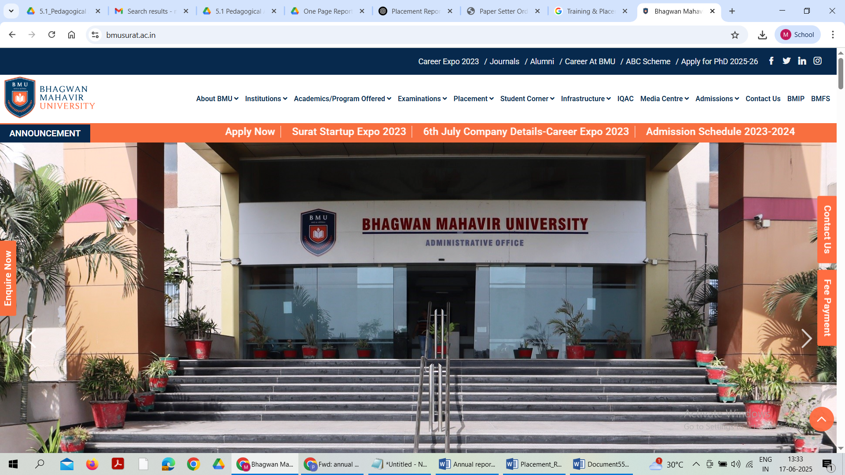
ANNUAL Report
2024-25

Bhagwan Mahavir School of Nursing
sr. No. | Content |  | Page No.
1 | Introduction
 | 1.1 | Brief overview of College
 | 1.2 | Vision & Mission related to students placement and career development
 | 1.3 | Objective of the placement cell for 2024-25
2 | Placement cell details
 | 2.1 | Name of placement officer/Coordinator.
 | 2.2 | Key Team members and their roles.
 | 2.3 | Contact details
3 | Key initiatives undertaken in 2024-25
 | 3.1 | Industry/Organizational/Industrial Exhibitions visits
 | 3.2 | Guest Lectures (Online/Offline) by experts from Industry, Research and Academic Institutes.
 | 3.3 | Career Guidance and Higher Studies
 | 3.4 | Personality Development Classes
 | 3.5 | Training on Technical Skills
 | 3.6 | Internships
 | 3.7 | Employability Skill (Soft Skill Trainings -Mock Aptitude Tests and Interviews).
 | 3.8 | Memorandum of Understanding (MOU’s.)
 | 3.9. | On Campus Placements
 | 3.10 | Job Fair
4 | Placement statistics (2024-25)
5 | Top recruiters
6 | Alumni interaction and industry connect
7 | Testimonials/Feedback
8 | Future plan of action (2025-26)
9 | Conclusion
10 | Photo gallery

1. Introduction
1.1 Brief overview of the college/institute.
Bhagwan Mahavir School of Nursing Provides structured training and practical experience to individuals aspiring to become nurse. These institute focus on equipping students with the necessary knowledge, skill, and practical experience to excel in health care field, while also assisting them in securing employment through various placement services.

1.2 Vision and mission related to student placement and career development
VISION:
To produce “Global Competent Nurse” with clear ethical thinking skill who are caring motivated, well-disciplined and compassionate, adoptable to the changing needs of nursing profession health care system and society.
MISSION
- To promote professionalism by imparting quality of health care
- To conduct more innovative research activities which will make our students to acquire more knowledge and skill about new trends about health care
- To promote ethical and well-disciplined qualities among our students by impairing value added education
1.3 Objective of the placement cell for the academic year 2024–25.
- To facilitate student employment, provide career guidance and enhance their employability skills
- To provide career guidance
- To enhance Employability
- Bridge the gap between Acadamic and industries/Hospital/Company

2. Placement Cell Details
2.1 Details of Placement Officer/Coordinator.
Pinal Patel
Nursing Tutor
T.P.O Nursing Department
Mail Id-pinal.patel@bmusurat.ac.in

2.2 Key team members and their roles.1
SR.NO | NAME | DESIGNATION | ROLE
1 | Mr.Sujit Pilli | Nursing Lecturer | Assistant TPO
2 | Mrs Priyanka Bhatt | Assisstant Lecturer

2.3 Contact details.
1 | Mr Sujit Pilli | 8000159554
2 | Mrs Priyanka Bhatt | 9099027431

3.0 Key initiatives undertaken in 2024–25 including following:
    - Industry/Organisational/Industrial Exhibitions visits.
    - Guest Lectures (Online/Offline) by experts from Industry, Research and Academic
Institutes.
    - Career Guidance and Higher Studies.
    - Personality Development Classes.
    - Training on Technical Skills.
    - Internships.
    - Soft Skill Trainings (Mock Aptitude Tests and Interviews).
    - MOU’s.
    - On Campus Placements
    - Job Fair.

3.1.1 Industry / Organisational / Industrial Exhibitions visits.

Summary writeup
Name of college | Department | Year | Date | Details | No of students visited
BMSN | NURSING | 2025 | 20/06/2025 | Blind school visit Adajan ,Surat | 57
BMSN | NURSING | 2025 | 24/06/2025 | Sewage plan visit | 51
BMSN | NURSING | 2025 | 13/06/2025 | Sumul dairy visit | 51
BMSN | NURSING | 2025 | 10/06/2025 | Water purification plan visit | 51

3.1.2. Guest Lectures by experts from Industry, Research and Academic Institutes:
Summary writeup
Name of college | Department | Year | Date | Details | No of students attended
BMSN | Nursing | 2024 | 9/5/2024 | “Protection Against Cervical Cancer” | 236
BMSN | Nursing | 2024 | 3/8/2024 | Carrier Counselling | 236
BMSN | Nursing | 2025 | 16/1/2025 | “Ashmita-Mental Health Awareness” | 236BM

3.1.3. Career guidance and higher education:
Summary writeup
Name of college | Course | Date | Details | No of students attended
BMSN | Nursing | 29/4/2024 | “Career Guidance Seminar” | 236
BMSN | Nursing | 2/6/2025 | “In-services Education” | 236

3.1.4. Personality development Classes:
Summary writeup.
Name of college | Department | Year | Date | Details | No of students attended
BMSN | Nursing | 2025 | 21/3/2025 | “Mental Health Awerness” | 200

3.1.5. Training on Technical skills.
Summary writeup
Name of college | Department | Year | Date | Details | No of students attended
BMSN | Nursing | 2024 | 23/4/2024  24/4/2024 | Basic First Aid Traning | 236
BMSN | Nursing | 2024 | 20/11/2024 | Basic Life Support(BLS) Training | 236
BMSN | Nursing | 2025 | 7/4/2025 | Cardio Pulmonary Resuscitation (CPR) Training | 236

3.1.6. Internship:
Summary writeup
Name of college | Department | Year | Date | Details | No of students attended
BMSN | Nursing | Outgoing GNM 2024 | March 2024 | New Civil Hospital,surat | 24
BMSN | Nursing | Outgoing Basic Bsc 2024 | January 2024 | Maitry Hospital,Surat | 56B

3.1.7. Soft Skill Trainings (Mock Aptitude Tests and Interviews)
Summary writeup
Name of college | Department | Year | Date | Details | No of students attended

3.1.8. MOU’s
Summary Write-up
Name of college | Department | Date of Signing MOU | Organization with which MOU was signed | Details including Scope of MOUs | Remarks
BMSN | Nursing | 11/03/2025 | Shelby Hospital; Surat | There are multiple scope for clinical teaching like various disease patient and teaching of o.t side and also documentation
BMSN | Nursing | 9/10/2025 | Maitry Hospital; Surat | Same
BMSN | Nursing | 8/7/2025 | Universal Hospital | Same
BMSN | Nursing | 19/5/2025 | United Green Hospital | Same
BMSN | Nursing | 16/05/2025 | An and Hospital | Same

3.1.9 On Campus Placements:
Summary Writeup
3.1.9.1 Company-wise List of students selected/shortlisted: (SUMMARY SHEET)
Name of college | Date | Name of Company | No. of Students Selected/Shortlisted | Annual Package offered | Remarks

3.1.9.2 Details of Placed Students Academic Year 2024-25
Name of college | Department | Name of Students | Name of Company | Post | Annual Package
BMSN | Nursing | All students are placed(GNM-2024) | Varies Hospital | Staff Nurse | 1,80,000
BMSN | Nursing | All students are placed(BSC-2025) | Varies Hospital | Staff Nurse | 2,16,000
BMSN | Nursing | All students are placed(GNM-2025) | Varies Hospital | Staff Nurse | 1,80,000

3.1.9.3 Students selection for Job statistics (SUMMARY SHEET)
Name of college | Department / Program | Year | Total No. of Students in Final Year | Total No. of students interested for Job | No. of Students selected/placed
BMSN | Nursing | Outgoing GNM-2024 | 34 | 34 | 34
BMSN | Nursing | Outgoing BSC Nursing-2025 | 56 | 56 | 56
BMSN | Nursing | Outgoing GNM-2025 | 23 | 56 | 56

4. Placement Statistics (2024–25)
Insert table with placement data such as:
- Total Number of Eligible Students
- Number of Students Placed
- Placement Percentage
- Number of Companies Visited
- Highest Package Offered
- Average Package Offered
- Lowest Package Offered

6. Top Recruiters
List of top recruiters with logos (optional) and brief descriptions.

7. Alumni Interaction and Industry Connect
Details of alumni involvement and industry webinars.

8. Testimonials
Student testimonials and recruiter feedback.

9. Future Plan of Action (2025–26)
Strategies for upcoming academic year.

10. Conclusion
Summary and acknowledgments.

Annexures (Optional)
Detailed company-wise placement list, student-wise data, and event photos.

PHOTO GALLERY
