Start up Workshop: Turning Ideas into Action.
23rd July 2025
Bhagwan Mahavir College of Pharmacy

A startup workshop is a short, intensive program that helps aspiring entrepreneurs understand how to turn an idea into a viable business. It brief with the wellknown Speaker Mr.Sagar Patil with hands-on activities so participants can immediately apply what they learn. The session served as a platform to foster academic curiosity, professional development, and a deeper appreciation of the pivotal role clinical research plays in advancing global healthcare.
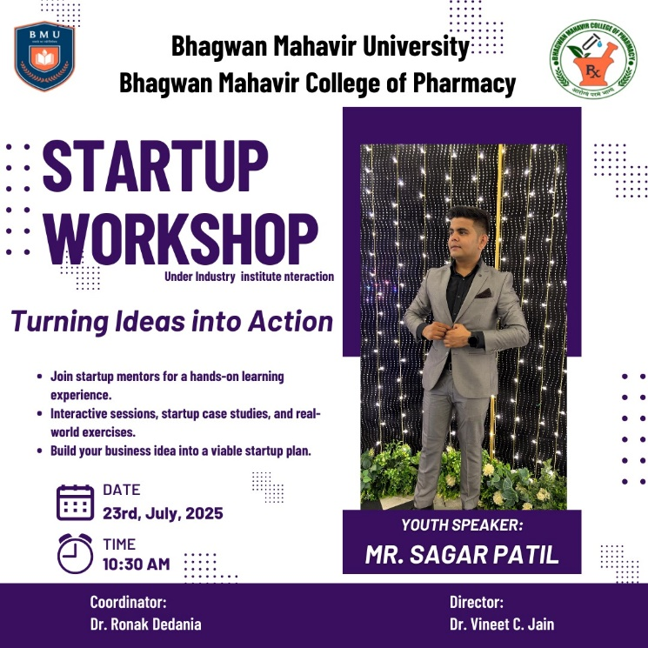
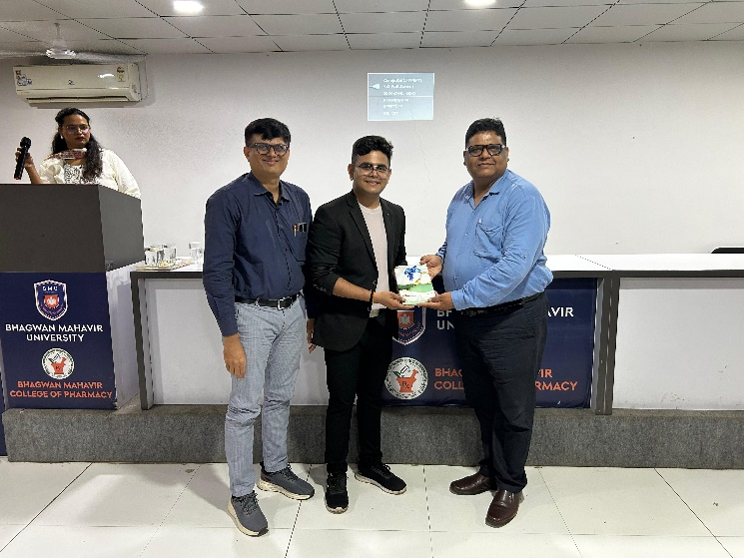

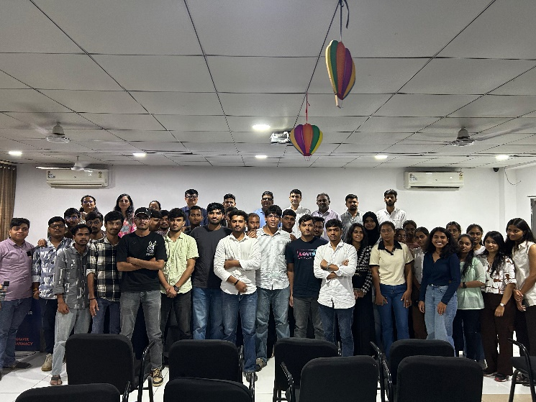

Research and Innovation Presentation Competition “5 year milestone of the policy (NEP)2020”

31st July 2025
Bhagwan Mahavir College of Pharmacy

The National Education Policy (NEP) 2020 marked a historic shift in India’s educational vision by placing research, innovation, and knowledge creation at the core of national development. Over the last five years, the policy has sought to move higher education institutions from being primarily teaching centers to becoming vibrant hubs of inquiry, creativity, and problem-solving.
NEP 2020 clearly recognized that India cannot aspire to be a global knowledge leader without a strong ecosystem for research and innovation across disciplines. It proposed structural reforms such as the National Research Foundation (NRF), greater institutional autonomy, and integration of multidisciplinary learning to catalyse high-quality research output and foster an innovation culture among students and faculty .The competition was held with 45 partcipants.

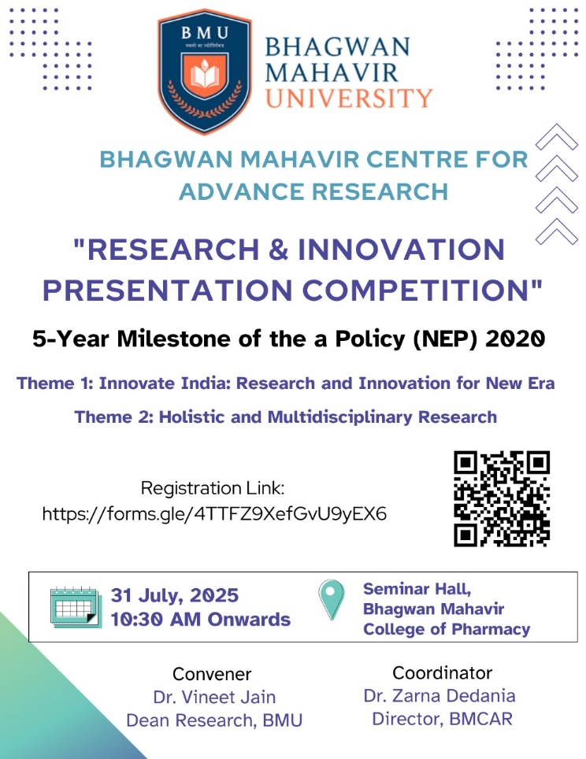

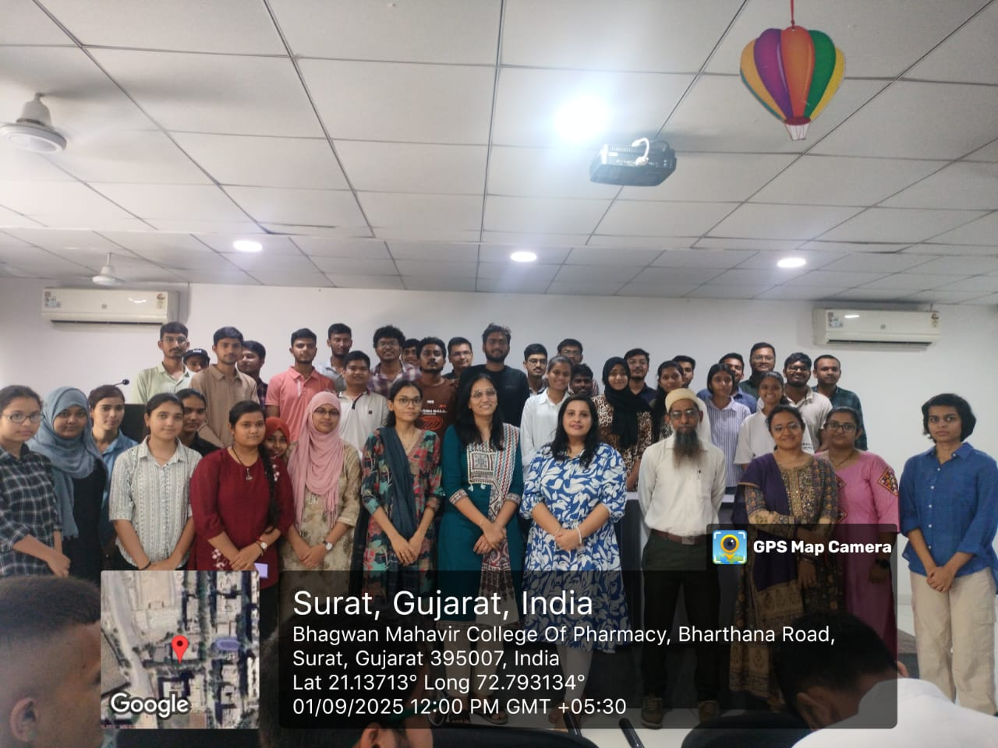

Triranga Yatra
10th Aug 2025
Bhagwan Mahavir College of Pharmacy.
On August 10th, the spirit of patriotism and national pride was in full display during the Triranga Yatra held in Surat. The event, organized to commemorate India's 79 th Independence Day, saw participation from people across different age groups and communities. The yatra, which translates to "Three Colors March," symbolized the unity and diversity of India, represented by the tricolor flag.
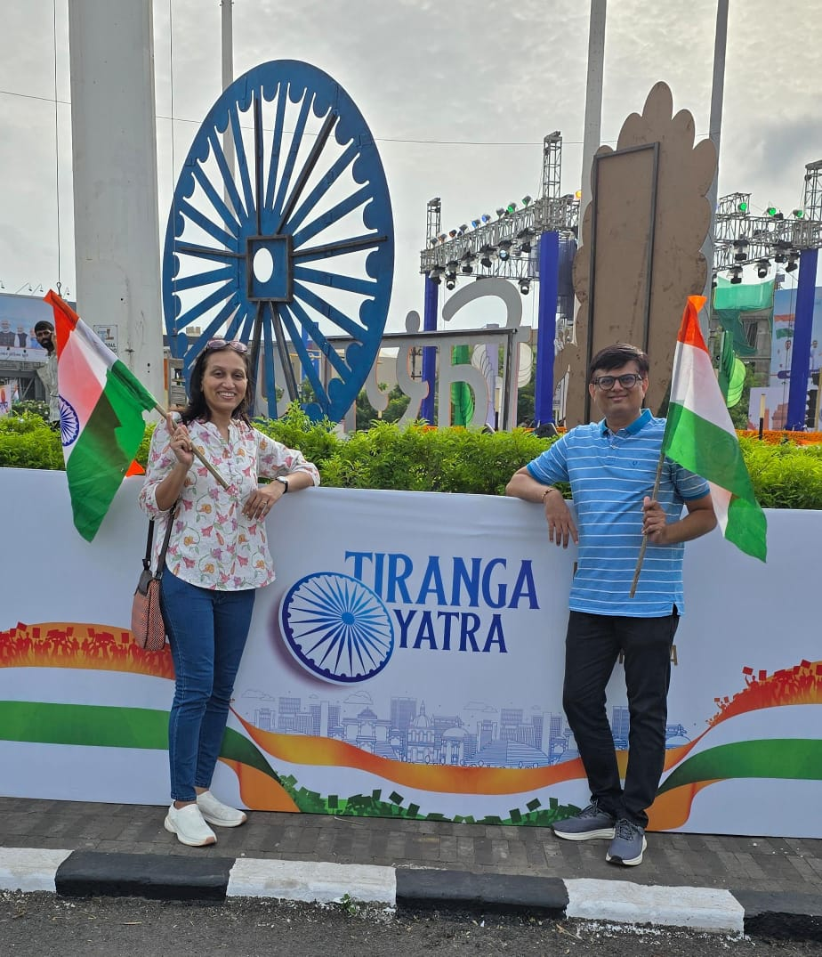

Independance Day

15th Aug 2024

Bhagwan Mahavir College of Pharmacy.

Bhagwan Mahavir University, Surat had Celebrated 79th Independance Day on 15th August, 2025. In the Presence of All Members Flag Hosting ceremony was celebrated. Firstly, Flag Hosting was done near BMIS Ground after that the Cultural Programme and Speech of Chief Guest was done in BMIS Auditorium. There was total 9 Performance including Speech, Solo Dance, Group Dance and Singing.

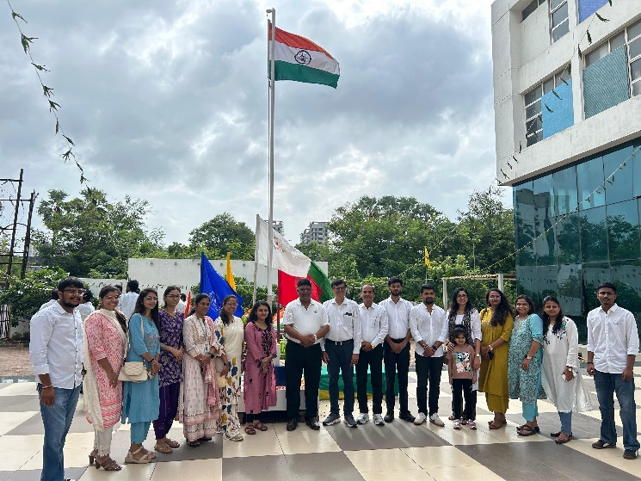

One Week for Nation “Heritage Walk”
19nd Aug 2025
Bhagwan Mahavir College of Pharmacy.

As a part of the grand celebration of the “One Week for Nation” initiative at Bhagwan Mahavir University (BMU), the Bhagwan Mahavir College of Pharmacy(BMCP) and the Faculty of Engineering (FOE) jointly hosted the Know India’s Heritage through Heritage Walk on 19th August 2025 at the Surat Castle, Near Dakka Ovara, Makai Pull, Chock Bajar, Surat.
As a part of the One Week for Nation celebration, Bhagwan Mahavir University organized a Heritage Walk for its students at the historic Surat Castle. The initiative aimed to promote awareness about India’s rich cultural and architectural heritage, while fostering a sense of pride and responsibility among students towards preserving historical monuments.
Entry Fees: ₹100 per participant
Surat Castle, built in the 16th century by Sultan Mahmud III, is one of the most prominent historical landmarks of Surat. Constructed as a defense fort against Portuguese attacks, the castle represents the city’s glorious past and its importance as a trade hub. Its magnificent stone architecture, bastions, and strategic location near the Tapi River reflect the engineering brilliance of its era.
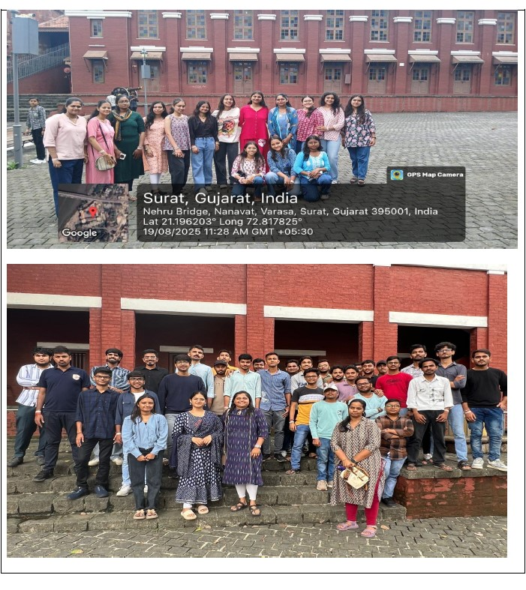

Career Guidance For B.pharm and D.pharm
25-26th Aug 2025
Bhagwan Mahavir College of Pharmacy.

Career guidance plays a pivotal role in shaping the professional journey of students pursuing Bachelor of Pharmacy (B.Pharm) and Diploma in Pharmacy (D.Pharm). As the pharmaceutical sector expands rapidly in India and across the world, students often face confusion about which direction to choose—industry, clinical, regulatory, academic, or entrepreneurial. This is where GDC (Guidance and Career Development Cell) steps in, providing structured support to help pharmacy students make informed choices based on their interests, strengths, and evolving opportunities in the healthcare ecosystem. GPAT discussion centre lecture gave dept knowledge of the subjects to students .Nearly 100 students including b.pharma n and D.Pharma took part in the lecture.

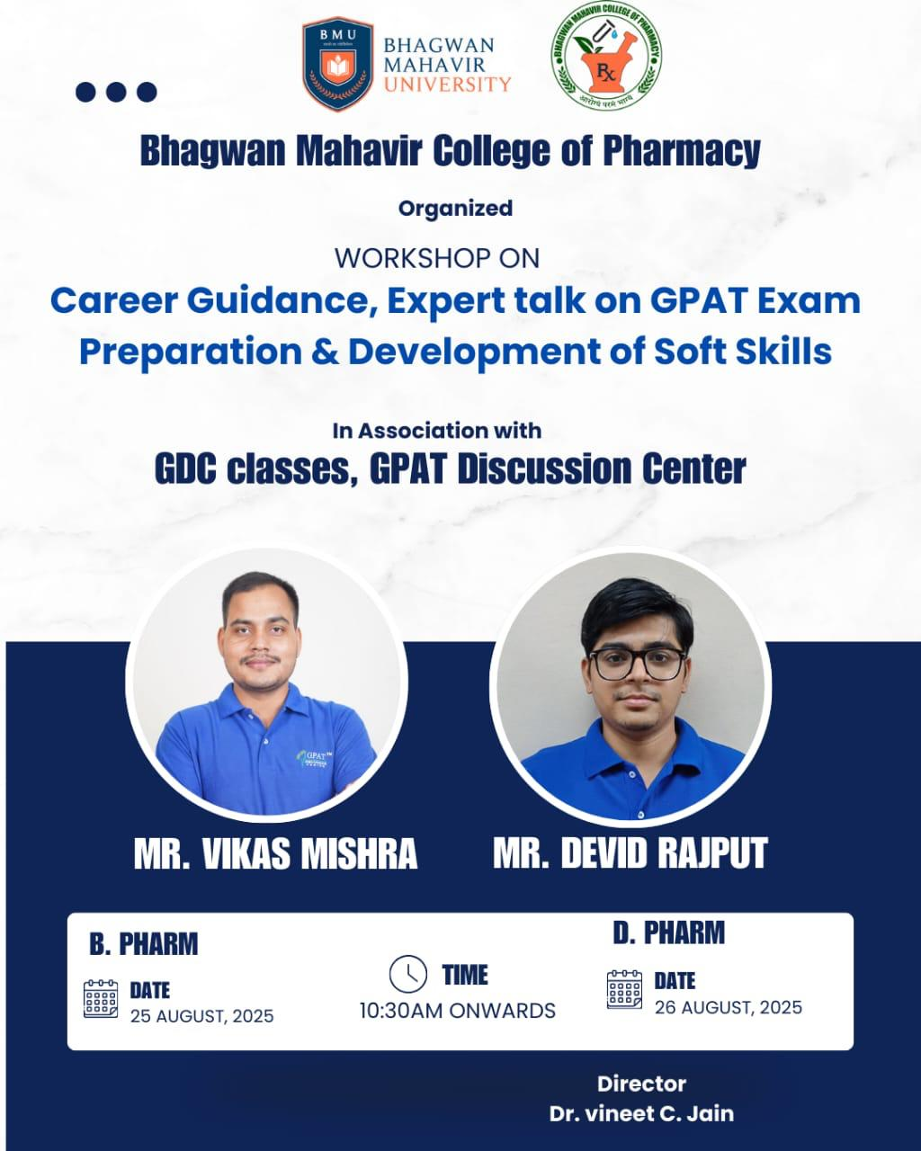

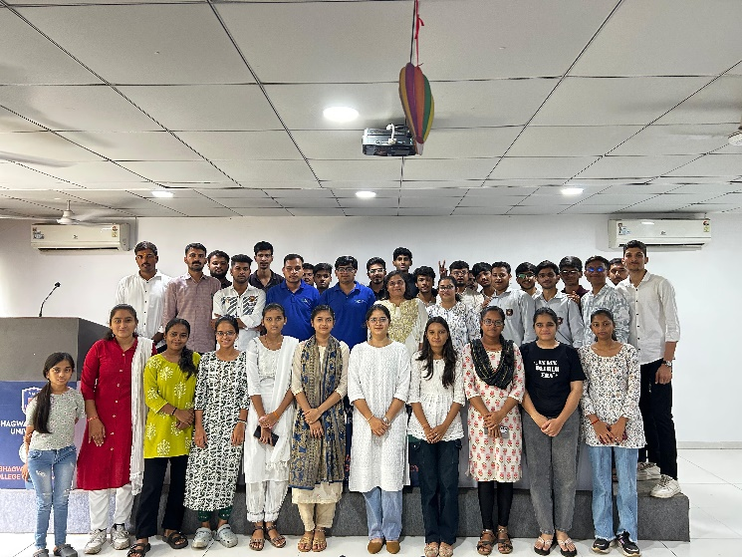
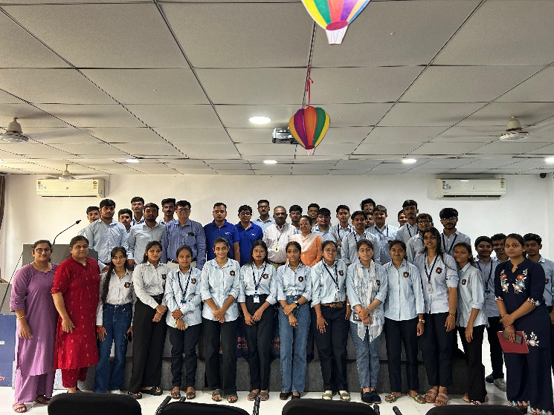

Clinical Research : Unveiling Future of Healthcare

28rd Aug 2025.
Bhagwan Mahavir College of Pharmacy.
In the ever-evolving landscape of healthcare, clinical research stands at the forefront of medical innovation, ensuring that new treatments are safe, effective, and aligned with patient needs. Recognizing the growing significance of this field, Bhagwan Mahavir College of Pharmacy, under the aegis of Bhagwan Mahavir University, organized an insightful seminar titled “Clinical Research: Unveiling Future of Healthcare” on 28th August 2025.
The primary aim of this seminar was to expose students and faculty to the dynamic world of clinical research, covering critical aspects such as clinical trial phases, regulatory requirements, and audit readiness. By inviting an experienced industry professional, the event aimed to bridge the gap between academic learning and real-world clinical practices, thereby equipping future pharmacists and researchers with a comprehensive understanding of the field.
The session served as a platform to foster academic curiosity, professional development, and a deeper appreciation of the pivotal role clinical research plays in advancing global healthcare. The event proved to be highly beneficial for the academic and professional development of the participants. Mr. Bhargav Joshi’s expertise, real-world experiences, and engaging delivery enriched the audience’s understanding of clinical research processes. The session not only addressed the scientific and regulatory framework but also emphasized the importance of integrity, protocol adherence, and patient safety in clinical trials. Overall, the seminar was an inspiring and knowledge-driven experience that aligned perfectly with the college’s vision of promoting excellence in pharmaceutical education

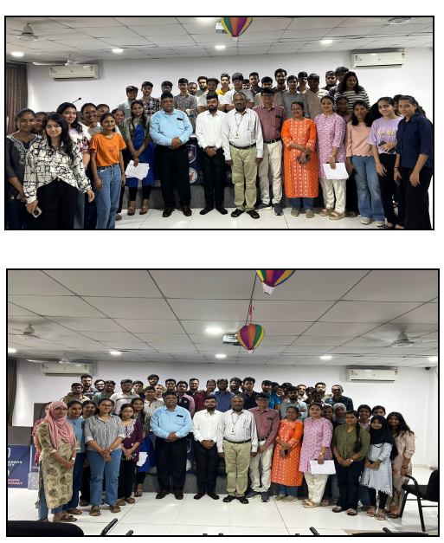
Pre-Employment Training Session
1st September 2025
Bhagwan Mahavir College Of Pharmacy
A well-designed pre-employment training program plays a pivotal role in preparing students for the competitive professional world. To ensure that final-year students step confidently into their careers, our institution organized a comprehensive Pre-Employment Training Session, aimed at equipping participants with essential skills, industry insights, and practical guidance. The event was a major highlight of this academic year and proved to be highly enriching for all attendees.
The session was designed with the objective of bridging the gap between academic learning and industry expectations by an expert Ms.Shrinki Mehta. Today’s recruiters look beyond academic excellence—they expect candidates to possess strong communication abilities, problem-solving competence, professionalism, and job-readiness. Recognizing this, the pre-employment training addressed all key components required for a smooth transition from campus to workplace.

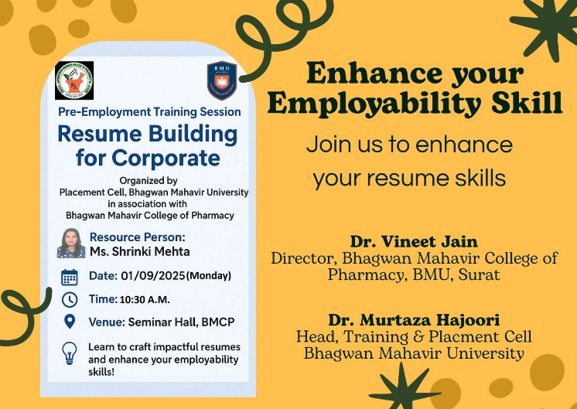

Ganesh Utsav
2nd September 2025
Bhagwan Mahavir College of Pharmacy.

Bhagwan Mahavir College of Pharmacy, Surat had Ganesh Aarti programme on 02nd September 2025. The evening Aarti for Ganesh Utsav was a beautiful and spiritually experience. Students and staff gathered at the venue by 4:30 PM, eagerly awaiting the arrival of Maharaj. About 40 students and staff participated in the celebration. As the students waited, they sang devotional bhajans, filling the atmosphere with melodious hymns dedicated to Lord Ganesha. Soon after, Maharaj arrived and commenced the puja, leading the sacred rituals with devotion and grace. Dr. Vineet sir, Dr. Zarna madam, Dr. Ronak sir actively participated in the pooja, assisting Maharaj in the offerings. After the Aarti, everyone sang the Thal in honor of Ganesh. The event concluded with the distribution of Prasad, which was enjoyed by all the students and staff, creating a sense of joy and togetherness. The students enjoyed the celebration, making the evening a memorable one for all
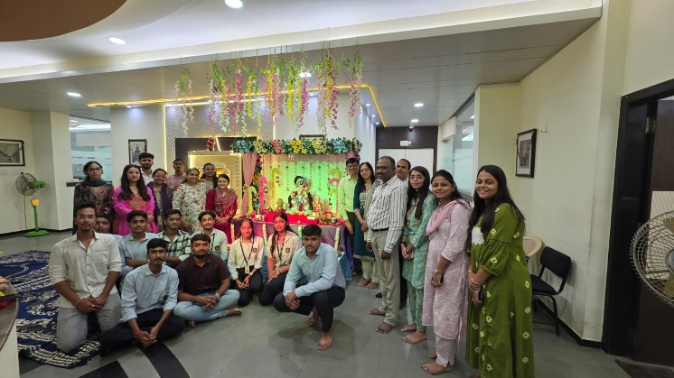
Teachers day Celebration

4th September 2025
Bhagwan Mahavir College of Pharmacy.

Teachers’ Day is a cherished occasion across India, celebrated every year on September 5th to mark the birth anniversary of Dr. Sarvepalli Radhakrishnan—an eminent philosopher, teacher, and the second President of India. To honor the dedication and invaluable contributions of the faculty members, our Pharmacy College organized a grand Teachers’ Day Celebration, creating a memorable and heartfelt tribute to the mentors who guide students not only academically but also in shaping their personal and professional growth.
The event brought together students, faculty, and staff in a spirit of gratitude, respect, and joy. This year’s celebrations were special, as they highlighted the unique role pharmacy educators play in nurturing future pharmacists, researchers, health-care professionals, and community leaders. The celebration began with an elegant welcoming ceremony organized by the final-year students. The auditorium was beautifully decorated with banners, flowers, and posters featuring thoughtful quotes emphasizing the power of knowledge and the impact of teachers. The ambience reflected warmth and reverence.The program opened with a traditional lighting of the lamp by the Principal Dr Vineet C.Jain , senior faculty members, and student representatives, symbolizing the spread of wisdom and enlightenment. This was followed by a melodious Saraswati Vandana, inviting blessings from the goddess of knowledge.
The student coordinator delivered the welcome address, highlighting the contributions of teachers in shaping the standards of pharmaceutical education and ensuring that students become responsible health-care professionals. The audience responded with applause and enthusiasm, setting a positive tone for the event.The Principal delivered an insightful and inspiring message, emphasizing the significance of Teachers’ Day not only as a celebration but also as a reminder of the responsibility entrusted to educators. He appreciated the faculty for their commitment to excellence, continuous learning, and mentorship—qualities that uphold the college’s reputation and shape the careers of numerous students.


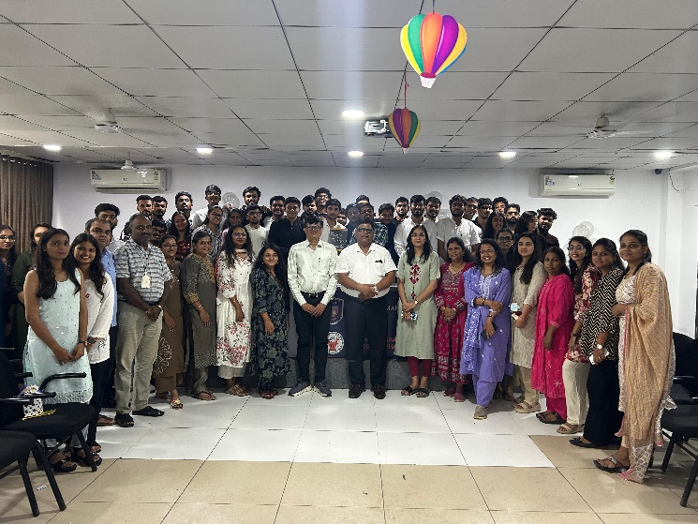
Navratri Celebration
26th September 2025
Bhagwan Mahavir College of Pharmacy.

The program began with a graceful inaugural ceremony in the college quadrangle, beautifully decorated traditional motifs representing the nine forms of Goddess Durga. The vibrant décor created an atmosphere of devotion and festivity.
The Principal Dr.Vineet C Jain, faculty members, and student representatives jointly performed the lighting of the lamp, symbolizing purity, knowledge, and positivity. This was followed by a soulful Durga Aarti, which filled the environment with serenity and spiritual energy. The chanting of devotional hymns set a reverent tone, reminding everyone of the cultural and emotional significance of Navratri.
The Principal addressed the gathering, lighting how festivals strengthen unity and cultural identity. He encouraged students to participate wholeheartedly and to cherish the cultural richness that events like this bring to academic life. Best Dress code competition and Best Garba Competition were given to students and staff.

Sr No | Date | Event
1 | 22/09/2025 | Heath awareness Seminar on Tuberculosis
2 | 23/09/2025 | Pharmatoons
3 | 24/09/2025 | Slogans
4 | 26/09/2025 | Documentary/Reels
5 | 27/09/2025 | Rhymes
6 | 30/09/2025 | Prize Distribution ceremony
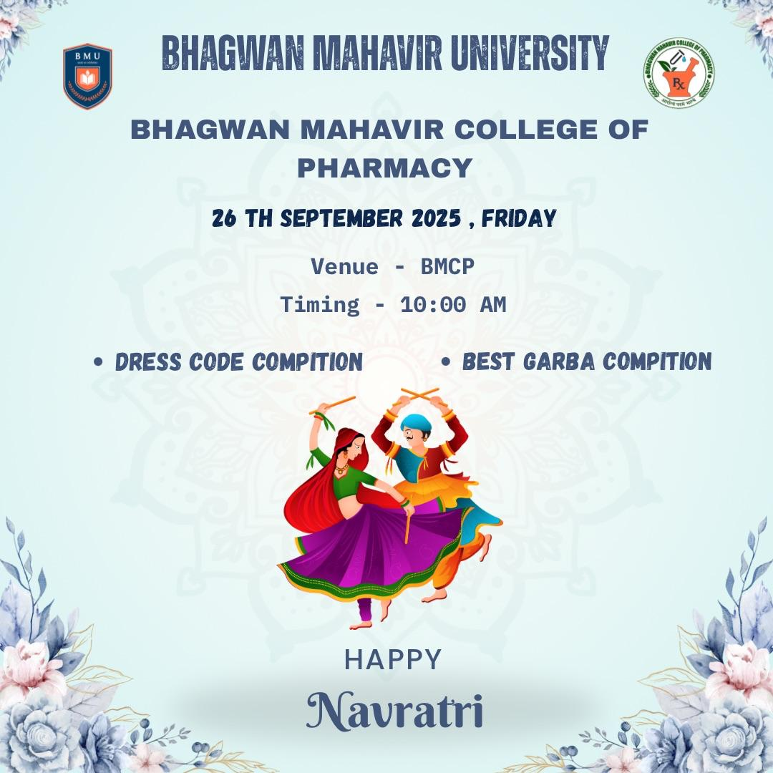
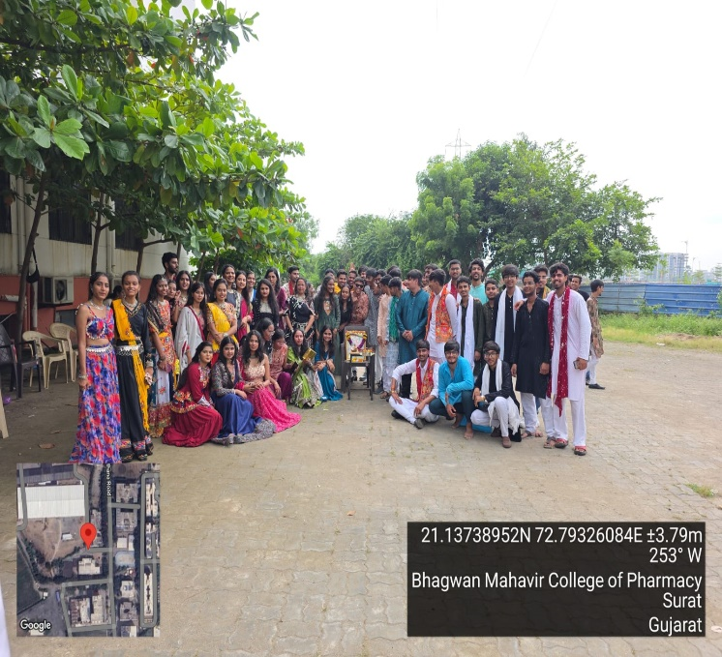
Pharmacist Week Celebration

23rd Sep-30th Sep 2025

Bhagwan Mahavir College of Pharmacy
The "World Pharmacist Day celebration held during 23rd-30th sept on theme of Think Health Think Pharmacist." is a comprehensive program sponsored by the Gujarat State Pharmacy Council and organized by Bhagwan Mahavir College of Pharmacy. The celebration aimed to raise awareness about the pharmacist’s contribution to global health systems and to inspire the integration of pharmacy expertise into all aspects of health policy and patient care.
