Republic day 2025.
26th January 2025

Bhagwan Mahavir University, Surat had Celebrated
76 th Republic Day on 26th January, 2025.The event was inaugurated at 08:30 AM in the
Presence of Chief Guest, Managing trustees of
BMU and Staff Members of Bhagwan Mahavir
University.In the Presence of All Members Flag Hosting
ceremony celebrated. All other members of
university including Students at BMIS.
Cultural events like Solo Singing , Dance,
Poetry was Performed by different Students
of University and School.

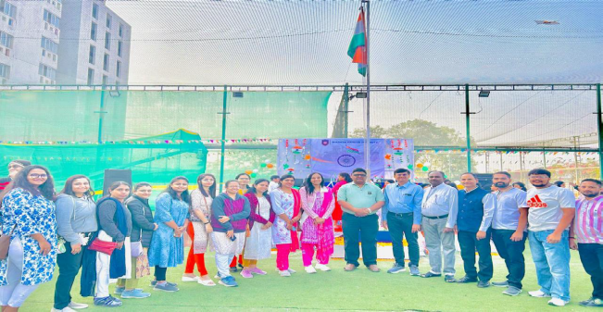

One-Day Workshop on Hydrotropic Analysis of Drugs

08 th Feb 2025

The Bhagwan Mahavir College of Pharmacy successfully conducted a One-Day Workshop on Hydrotropic Analysis of Drugs, emphasizing environmentally friendly or "green" analytical methods. The workshop was graced by the presence of Dr. R.K. Maheshwari, who served as the resource person for the event. The program commenced at 10:30 AM with the traditional lamp lighting ceremony. This was followed by a warm welcome and brief introduction of Dr. Maheshwari by our respected Director, Dr. Vineet C. Jain.
Dr. Maheshwari then delivered an insightful and engaging lecture lasting about 1.5 hours, where he discussed the principles and applications of Hydrotropic Analysis and its role in promoting green analytical chemistry. His presentation offered valuable perspectives on replacing hazardous organic solvents with safer alternatives, aiming to make pharmaceutical analysis more sustainable.
Following the theoretical session, participants moved on to the practical demonstration segment, where Dr. Maheshwari guided students through various experimental techniques such as Thin Layer Chromatography (TLC), titrations, and other relevant methods. These hands-on sessions greatly enhanced the participants’ understanding and enthusiasm.
The workshop concluded at 3:00 PM, leaving the attendees enriched with knowledge and inspired to adopt greener practices in pharmaceutical research and education. Students and faculty alike appreciated the interactive format and the depth of information shared throughout the day.
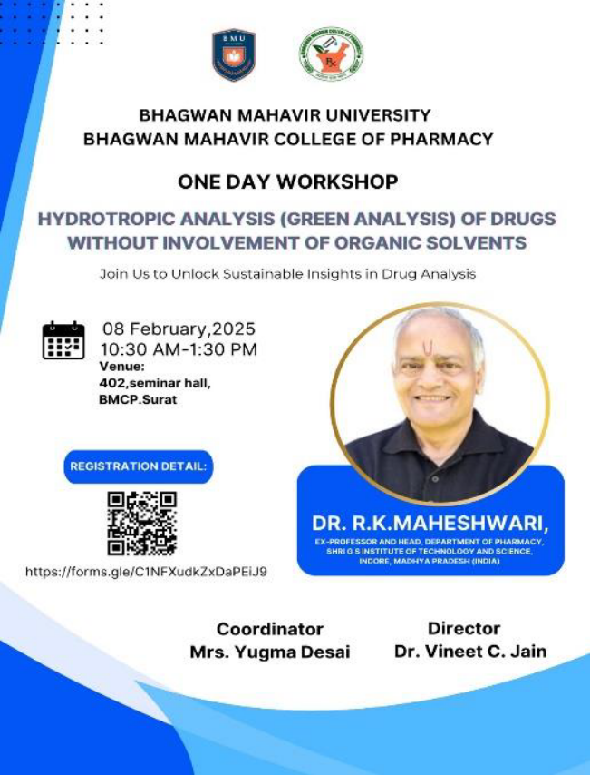
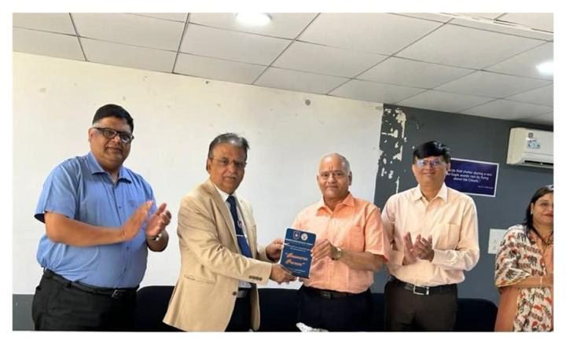

Two Days Online Refresher Course for Registered Pharmacist

15th & 16th February 2025

The "Two Days Online Refresher Course for Registered Pharmacists" is a comprehensive program sponsored by the Gujarat State Pharmacy Council and organized by Bhagwan Mahavir College of Pharmacy. This course is designed to cater to the ongoing professional development needs of registered pharmacists. It is essential for pharmacists to stay up-to-date with the latest advancements in the field to ensure that they provide safe and effective pharmaceutical services to the community. The course is scheduled to take place on the 7th and 8th of October 2023, over the course of two days. The detailed schedule ensures that participants can gain valuable insights and knowledge in a structured and time-efficient manner.

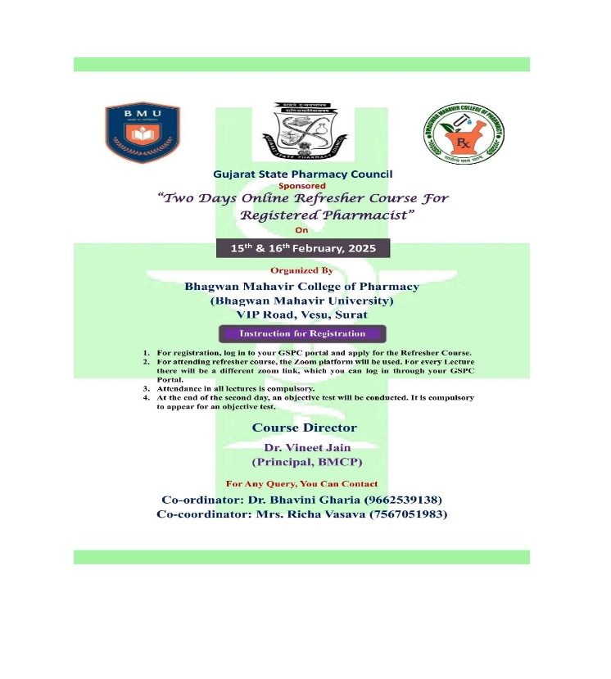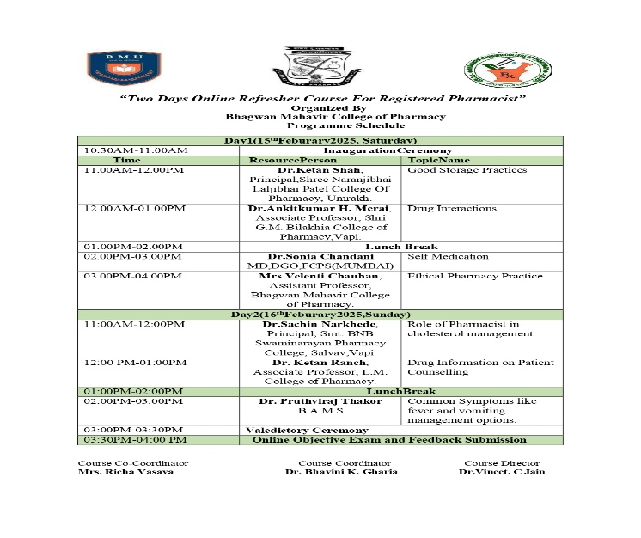

Sports Day-2025

20th Feb 2025 – 01st March 2025

Bhagwan Mahavir University, Surat, proudly organized its annual Sports Day celebrations from 20th February to 1st March 2025. The campus was buzzing with excitement as students, faculty, and staff came together to witness and participate in this grand sporting spectacle. The event was a true celebration of physical strength, endurance, discipline, and team spirit. A wide range of outdoor games were organized, including Cricket, Kabaddi, Kho-Kho, Volleyball, and Basketball. These events saw intense competition, enthusiastic cheering, and some truly remarkable athletic performances. Alongside the outdoor competitions, a series of indoor games were also held, offering a perfect balance for students who enjoy precision and focus-based sports. Events like Carrom, Badminton, and Table Tennis drew large crowds and displayed sharp reflexes and impressive technique from participants. The Pharmacy students stood out with their active involvement in all categories of games. Their spirit, sportsmanship, and teamwork added a special charm to the event. From the cricket field to the badminton court, they played with passion and dedication, making the department proud. Sports Day provided students with an opportunity to take a break from academics, build camaraderie, and create lasting memories.

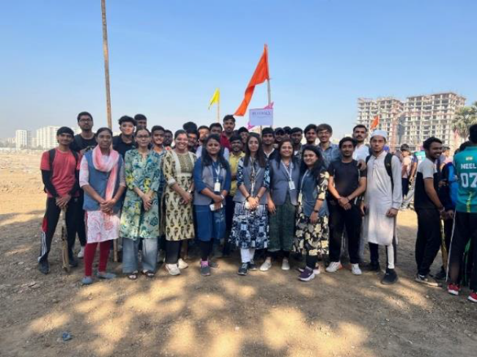
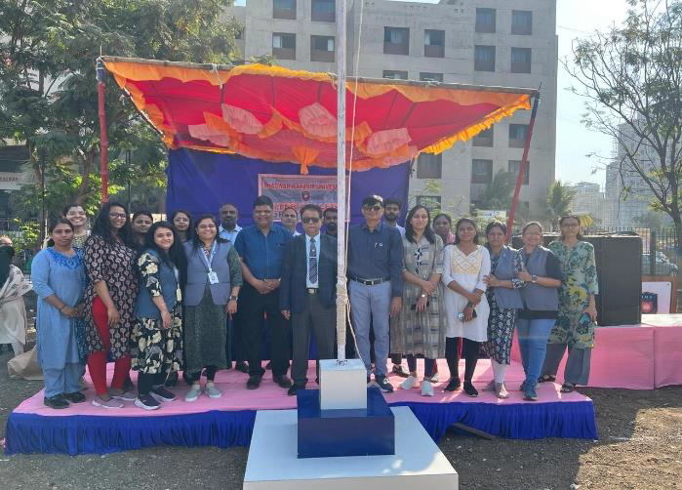
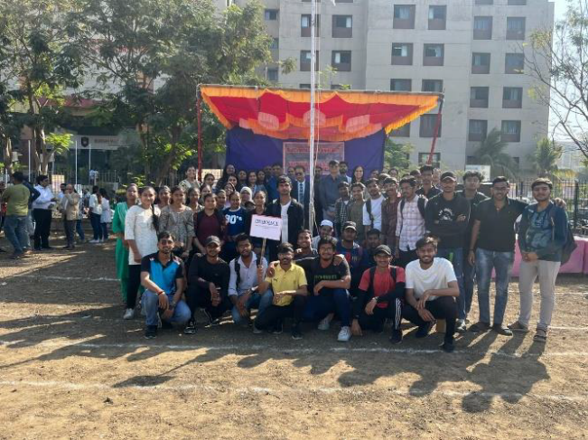

Pharmaphilic 2025

01st March 2025

Pharmaphilic symbolizes our passion for pharmacy — a profession that blends science, compassion, and innovation to improve human health. Today, we come together not just to compete, but to collaborate, to learn, and to grow. This fest is a unique platform designed by students, for students, to showcase talent and sharpen skills beyond the classroom. From technical event Poster Pulse, Pharma Marketing, Prescription Plates & Pharma Sketch for Non-Technical Event Reader Unlocking & Stack & Run— there’s something for every curious mind here. Let us use this occasion to build new connections, ignite new ideas, and celebrate the spirit of science and creativity. Together, let's make Pharmaphilic 2025 not just an event, but a memorable experience. The Event was Inaugurated in the Presence of Guest of Honor Mr. Arpit Jariwala, Manager: Research & Development, SMT & Shri Jignesh Patil, President Youth4Gujarat Charitable Trust Suart and Chief Guest Shri Praful Dhorajiya, Director GENMED Surat. In different events students took part from different college like S.S. Agarwal College, Maliba Pharmacy College, Sharee Naranji bhai College Umrakh, Dayaram College of pharmacy. Total 110 Students took Part in the event.
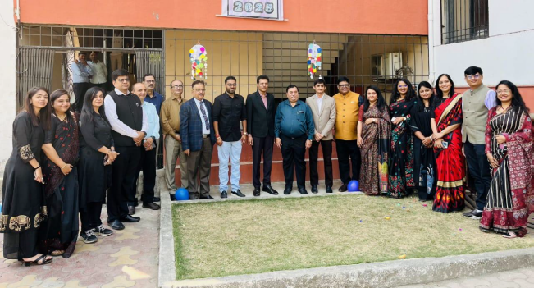

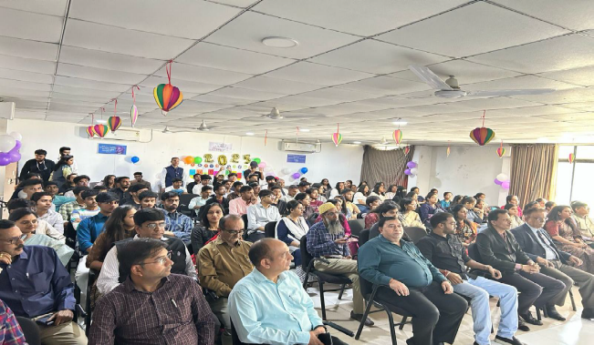

Days Celebration 2025

03rd March 2025 – 08th March 2025

The main purpose of this program was to provide a platform to the students to show their talent and improve their sports activity, presentation skills, communication skills and creativity. Bhagwan Mahavir College of Pharmacy Was celebrated Days. Which includes Mis Match Day Traditional day, Denim Day, Retro Day , Group Theme Day with Musical Morning & Twin Day and in sports there are Cricket Tug of War & Seven Stone , All the Students took part in celebration. Competition for all the days held for Students & Faculties
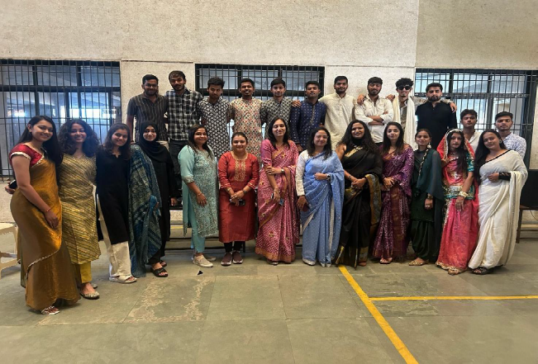

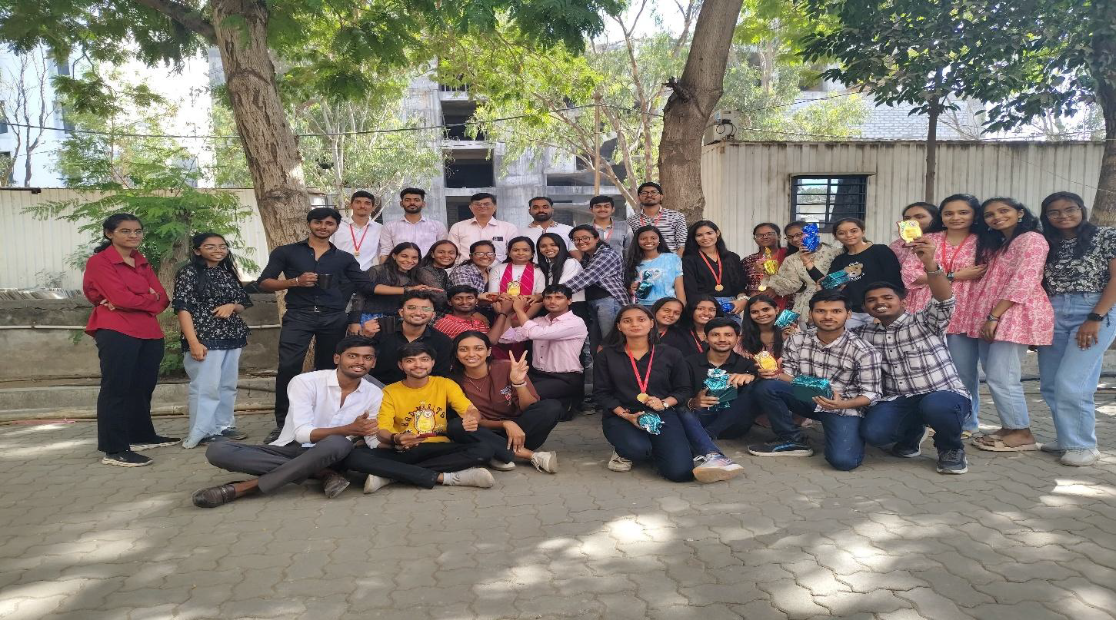

Spandan 2k 2025 (Annual Function)
10th -12th March 2025

Bhagwan Mahavir University, Surat had organized Spandan 2k 2025 (Annual Function) of all Colleges constituted in Bhagwan Mahavir University. The event was inaugurated at 06 P.M. in the presence of Managing trustees of BMU. On 10 March there was in house Activities were there which Includes Elocution, Debate, Antakshari, Face Painting, Reel Making & Nukkad Natak. Cultural Programme was there in which total 45 Entries were there. In the Event Different Competition were held like Dance (Solo, Duet, Group), Singing, Fashion Show, Talent Show. Along with the Cultural Event Annual Function was also there with Felicitation of Achievement of Students and faculties for the Academic Year. On 12 th March there was Celebrity Night in Presence of Rhythm Shashtri total Participation was More than 1000 on that day. In different Cultural event total 180 Students Participate From different Colleges. From Pharmacy total 02 Entries were there one for Solo Singing & one for Fashion Show from Bhagwan Mahavir College of Pharmacy. Pharmacy Students got 1st Price in Solo Singing.
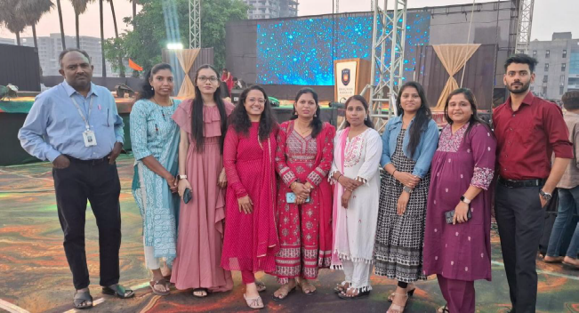

The elocution competition was held at 11.00 AM at BMCA Seminar Hall.
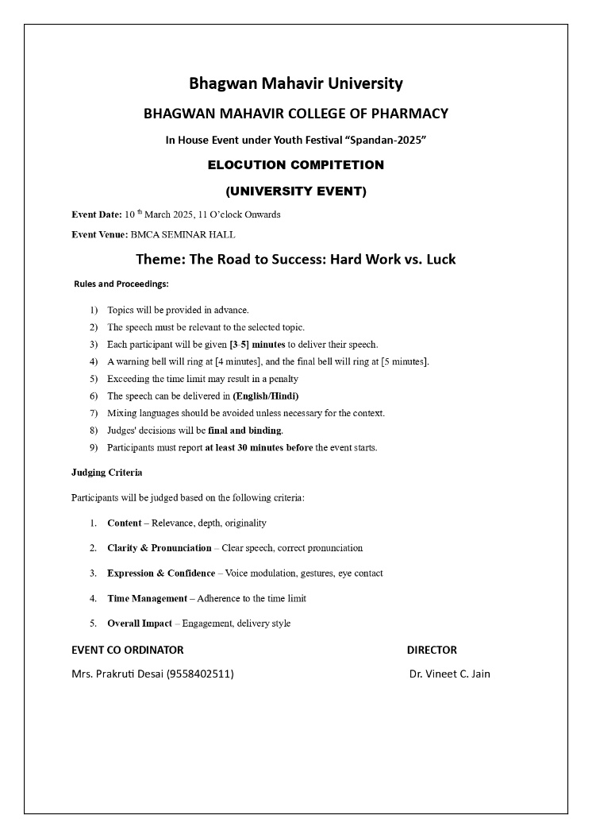

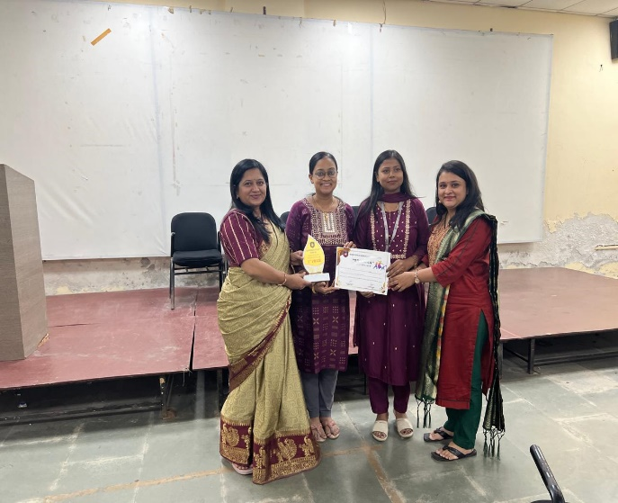

NSS Special Camp – 2025

24th March 2025 – 30th March 2025

As part of the NSS Camp organized by Bhagwan Mahavir University from 24th March to 30th March 2025 at Olpad, Surat, various colleges under the university participated actively, each conducting unique programmes throughout the week. On 29th March 2025, volunteers from Bhagwan Mahavir College of Pharmacy and the MBA College visited Kudiyana School, Olpad. The team departed by bus at 8:00 AM after having breakfast. Upon arrival, a brief interaction session was held with the school principal, teachers, and students. NSS volunteers conducted several activities, including: Tree plantation, Craft and drawing sessions, Health check-up camp, Awareness programmes on health, hygiene, and environment. At 2:00 PM, the volunteers proceeded to Sidhdhnath Mahadev Temple where lunch was served. Afterward, they visited a nearby beach for recreation. The team returned to the college campus by approximately 7:00 PM, marking the conclusion of a productive and enriching day.
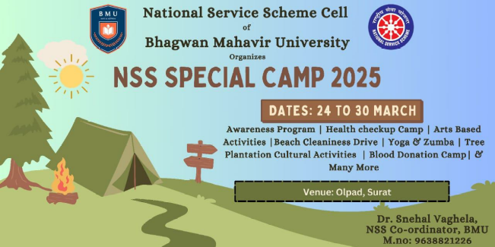
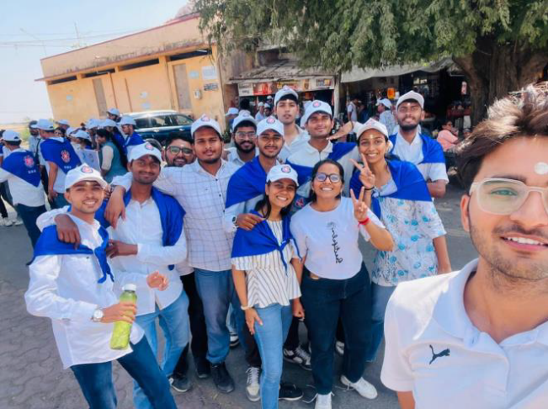

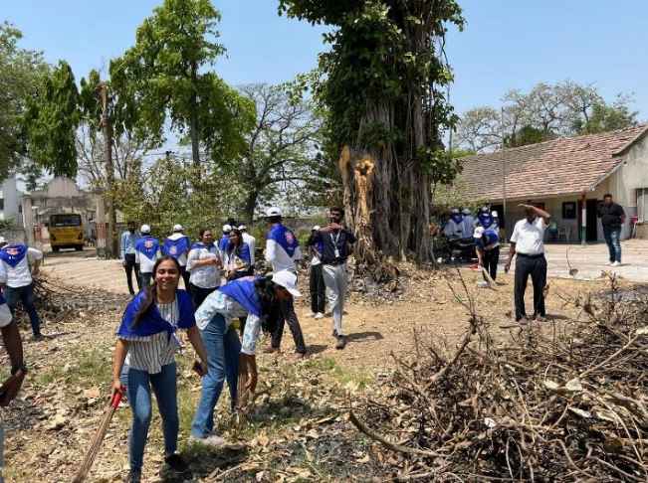

The Art Of Mind Control

28 ^{th} March 2025
The "Art of Mind Control" Seminar organized by Bhagwan Mahavir College of Pharmacy, are designed to help individuals harness the untapped potential of their minds through techniques rooted in ancient wisdom and modern mindfulness practices. These workshops aim to empower participants by teaching them how to tame their minds, improve focus, and lead more productive and joyful lives.
Event Starts with welcoming Guest Speaker , Staff and all the Participants from 2nd and 4th sem B.Pharm Students and by giving brief introduction of Guest Speaker by Dr Bhavini Gharia . Guest Speaker for the event felicitated by Dr.Vineet Jain sir and Dr.Ronak Dedania with memento respectively. Later, ‘THE ART OF MIND CONTROL’ session was started by Shri Pram Dhama Das ji.





